Third Party Notes & Summary Statement Guidelines
- Pre-K Second Edition- Observation Booklet (must be filled out entirely):
CLASS® Cycle Score Sheets (4 complete cycles):
Top Portion: | - Cycle Number  - Start Time  - End Time  - Number of Adults/Children | - 1-4  - Cycle start time (ex. 9:00 AM)  - Cycle end time (ex. 9:20 AM)  - Number of adults/children (ex: Adults 2 Children 20)
Initial Ranges |  | Write L, M, H next to each indicator to indicate initial range
Confirm Ranges |  | Circle confirmed range for each indicator
Dimension Score |  | Circle dimension score
Activity Setting (pg. 27 Field Guide) | - Format/Content Areas | Mark all that apply (use pg. 142 in Field Guide for content and format definitions)
Activity Setting (pg. 27 Field Guide) | - Time (T) | Circle the relative time spent in a particular content area
Activity Setting (pg. 27 Field Guide) | - Number of Children (N) | Circle the relative number of children involved in a particular content area
Activity Setting (pg. 27 Field Guide) | - Engagement Level (E) | Circle the degree of engagement of children in a particular content area
 | - Content Focus | Check the one content area focused on the most
CLASS® Observation Summary Sheet (pgs. 1-2)
Summary Scoring Sheet (pg. 1) | - Cycle Information  - Scores  - ASI Rating | Transfer all individual cycle information to summary scoring sheet.
Observation Summary  (pg. 2) | - Date  - Age/Grade Level  - Observer  - School/Classroom  - Educator(s)  - Language(s) | - Date of observation  - Pre-K  - Observer reliability code  - Classroom code  - Educator initials  - Language spoken
Dimension/Domain Averages | - Dimension Averages  - Domain Averages | - Indicate the two highest (H1 & H2) and lowest (L1 & L2) scoring dimensions next to dimension averages
Overall Scores from Portal |  | - Write overall score without Negative Climate under dimension averages chart

- CLASS® 2nd Edition Infant-Toddler Observation Booklet (must be filled out entirely)
CLASS® Observation Sheets (4 complete cycles):
Top Portion: | - Cycle Number  - Start Time  - End Time  - Number of Adults  - Number of Children Awake/Asleep | - 1-4  - Cycle start time (ex. 9:00 AM)  - Cycle end time (ex. 9:20 AM)  - Number of adults (ex. Adults 2)  - Number of children awake/asleep (ex. Awake 4 Asleep 2)
Initial Ranges |  | Write L, M, H next to each indicator to indicate initial range
Confirm Ranges |  | Circle confirmed range for each indicator
Dimension Score |  | Circle dimension score
Activity Setting (pg. 29 Field Guide) | - Format/Content Areas | Mark all that apply (use pg. 120 in Field Guide for content and format definitions)
Activity Setting (pg. 29 Field Guide) | - Content Exposure | Circle the degree of exposure to children in a particular content area
Activity Setting (pg. 29 Field Guide) | - Content Focus | Check the one content area focused on the most
CLASS® Scoring Summary Sheet
Summary Scoring Sheet (pg. 1) | - Cycle Information  - Scores  - ASI Rating | Transfer all individual cycle information to summary scoring sheet.
Observation Summary (pg. 2) | - Date  - Age  - Observer  - School/Classroom  - Educator(s)  - Language(s) | - Date of observation  - Infant, Infant-Toddler, Toddler  - Observer reliability code  - Classroom code  - Educator initials  - Language spoken
Dimension/Domain Averages | - Dimension Averages  - Domain Averages | Indicate the two highest (H1 & H2) and lowest (L1 & L2) scoring dimensions next to dimension averages
Overall Scores from Portal |  | Write overall score without Negative Climate under dimension averages chart

- All observation booklets must contain a printed Observation Checklist. The checklist must be filled out in its entirety and include any pertinent details.
- A simplified observation ticket/label must be securely taped to the back of the observation booklet. Include observer code, classroom code and date completed.

Observation Notes, Summary Statements and Highest/Lowest Feedback for all Age Types (Infant-Toddler or PreK)

- Observation Notes
- All observation notes should be written or typed on the required/approved notes pages and attached to the observation booklet next to each corresponding cycle.
  - All altered notes pages must be approved by the UL Lafayette CLASS administration.
  - If you require more space than allowed in the dimension box, please print multiple copies of the notes pages for each cycle so the notes stay organized by dimension.
- All dimension boxes must contain specific evidence to support the dimension score.
  - Never leave a dimension box blank
- All indicators must be addressed in notes.
- Provide a sufficient number of exact quotes, when applicable.
- A context or clarification statement should be added to support the numerical score.
  - Ex.). Small group activity coloring or matching butterflies; educator provides activity but time loss due to preparation or behavioral issues; educator asked many how/why questions but failed to provide adequate wait time for children to respond.
- If notes/examples fit in more than one dimension, you must reference the example or direct quote in both dimension boxes.
- Add descriptor terminology to strengthen notes to show the quality, depth and/or duration of evidence (i.e. warm voice -add consistently or with majority of children).
- Provide enough evidence to support the numerical score. For example, the evidence provided should indicate why the overall score is a “6” and not a “7”.

- Summary Statements
- Write summary statements that address each indicator with the following:
- A lead-in statement that addresses the indicator and frequency (past tense)
    - Ex). The educator and children consistently demonstrated genuine, connected relationships with one another.
- Specific examples unique to the observation
    - Ex). The lead educator got down on the children’s level while playing with blocks during center time and had a social conversation with one child about a sibling’s birthday party. The educators and children collaborated during morning routine discussions and smiled together while singing and dancing to the Good Morning Song.
- The number of specific examples provided must match the frequency term for the indicator.
Indicator Average Range | Frequency Terminology | Number of Examples for Summary Statements
High Range | Many, frequently, always | 4 or 5 examples
Mid-Range | Sometimes, occasionally, at times | 2-3 stronger examples with 1 lower quality example OR
Mid-Range | Sometimes, occasionally, at times | 2 stronger examples and 2 lower quality examples OR
Mid-Range | Sometimes, occasionally, at times | 2 lower quality examples with 1 stronger example
Low- Range | Rarely, Few, Does Not | 1 example or clarification statement  - Ex.) The educator asked rote questions throughout the observation, identifying shapes, colors, or numbers.

*The number of examples for each range (H, M, L) are a guide for reporting purposes ONLY and should not be used as a guide when scoring interactions.

- The specific examples must be written in one of two ways:
  - Written in grammatically correct sentences after the lead-in statement.
    - Ex.). For example, the educator provided leadership roles for several children during the morning routine including calendar helper, attendance taker, and weather helper.
  - Provided in parentheses and separated by semicolons after the lead-in statement.
    - Ex. 1). (sitting all together on rug with children; shared activities with sorting game; social conversation about weekend plans)
    - Ex. 2). (“Thank you for helping.”; “I appreciate you sharing with your friends.”; “I love the way you are being good listeners.”)
- Choose the strongest examples (including non-examples) that support the numerical score.
- The number of examples provided should include the examples and non-examples (low-quality examples). Ex.). The educator sometimes demonstrated respect for children (“Good job for putting your food up M.”; used polite language such as “Please and Thank you.”). At other times, the educator demonstrated less respect for children (without warning educator moved a child from rug into a rocking seat).
- The examples should include specific details and/or context when necessary.
Summary Statement Examples:
- Positive Climate Example (Pre-K): The educators and children consistently demonstrated genuine, connected relationships during the observation (throughout the snack routine, the educators were down on the children’s level at their tables and initiated social conversations with them through comments and questions such as “Ms. E! How did your soccer game go?”; there was matched affect and shared enjoyment between the educators and children as they laughed together when the lead educator playfully said, “I should kiss my brain!”; children showed positive relationships with their peers such as when one child worked to help his peer with the closure on his firefighter costume; educators used community oriented language such as “we” and “friends” during activities, “What can we do that is kind and loving for someone who is angry?”). The educators and children frequently displayed enjoyment (during a lesson on emotions, children hopped up and enthusiastically participated in singing a verse from ‘If You’re Happy and You Know It’; the lead educator and a child smiled as they worked together at the art table to create and color an octopus; children laughed aloud while playing together at a neighborhood table; children participated enthusiastically in answering the lead educator’s questions about what might make them feel afraid). There were many instances of positive communication between the educator and children (while hugging a child to her, the lead educator stated, “I’m going to give you a tight hug and squeeze!”; educators provided high fives to children when they shared ideas during activities or approached them with their creations in centers; the lead educator stated, “I love that you chose playdough! We can make some shapes!”; the lead educator stated, “That’s a neat ice cream cone!” and the child smiled in response; the second educator stated, “I love you!”). The educators and children frequently demonstrated respect for one another (educators used warm and enthusiastic voice tones; educators used children’s names during activities and interactions; educators used polite language such as “thank you” and “please”; children were cooperative with their educators’ instructions and with sharing their space and materials with their peers during centers).

- Behavior Guidance Example (Infant-Toddler): In this setting, some behavior expectations were developmentally informed (“Remember we put our paintbrush on the paper”), but at other times, they were not (children were expected to sit at a table painting for 15 minutes without being able to get up; when children put the paintbrush near their mouth, the educator pulled it away saying, “No, we don’t eat the paint.”). The educator was reactive and monitoring was ineffective or absent (educator had her back to children on rug while changing an infant’s diaper and one child pulled another child’s hair). The educator’s attempts to redirect behavior were ineffective; because of the ineffective redirection, challenging behaviors continued and/or escalated (child screamed after second instance of child pulling hair). This was observed on more than one occasion during the observation, as children pulled on one another and stole toys from one another.
- Facilitated Exploration Example (Infant-Toddler): The educator sometimes facilitated in ways that maximized children’s involvement in activities (initiated activities such as blowing bubbles; during a book reading, asked questions such as, "What does the duck say?"), while at other times, (the educator interacted less with infants who sat quietly in their seats or activity centers). In this setting, the children were sometimes interested in others or their experiences (child demonstrated interest in playing with the toy phone, picking up the phone and babbling). At other times, children showed a mix of engagement (children opened play kitchen and threw pretend food on the floor; a child pushed away a rattle as the educator continued to shake it in the child’s face). The educator rarely used play, routines, or activities to support children’s cognitive skills (the educator said, “phone” when the child picked up the play phone but did not ask what the child was trying to say or who the child was talking to). The educator rarely provided scaffolding to children who struggled (when infant laid on belly and tried to grab the toy block, the educator simply gave the child the toy block with recognizing the child’s effort).
- Guidelines for Selecting Feedback:
Highest Scoring Dimensions (Infant-Toddler and PreK)
- Once the observation scoring summary sheet is filled out completely, review the dimension score averages and select the highest two averages (indicate which two you have selected with H1 and H2).
- If you have multiple dimensions with the same average score, select no more than 1 dimension in each domain (This only occurs if you have three or more dimensions with the same average score. If you have only two dimensions with the same score those should be chosen).
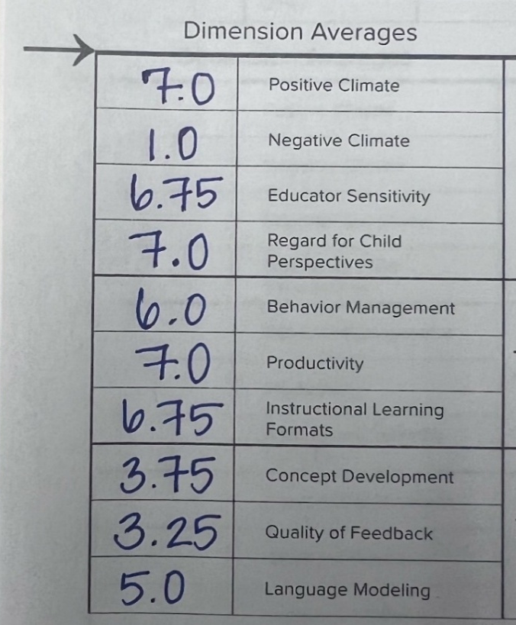
Example (Pre-K) - Positive Climate (PC), Regard for Child Perspectives (RCP) and Productivity (P) are all assigned a score of a 7. You would address one dimension in Emotional Support (either PC or RCP) and P in Classroom Organization.
H1
3. If more than 1 dimension is assigned the same score in the same domain, use your judgment to determine which dimension was most strongly supported by higher-level behaviors.
H2
Example (Infant-Toddler)- Positive Climate (PC), Educator Sensitivity (ES) and Behavior Guidance (BG) are all assigned a score of a 6. You would decide which two dimensions of the three strongly support higher-level behaviors.
L2
L1
4. If all dimensions are scored below a 3, there is no highest scoring dimension to address.
NOTE: We are excluding Negative Climate when selecting the highest scoring dimension.
Lowest Scoring Dimensions (Infant-Toddler and PreK)
      - Review the dimension score averages and select the lowest two dimension averages (indicate which two you have selected with L1 and L2).

      - If you have multiple dimensions with the same average score, select no more than 1 dimension in each domain (This only occurs if you have three or more dimensions with the same average score. If you have only two dimensions with the same score those should be chosen).
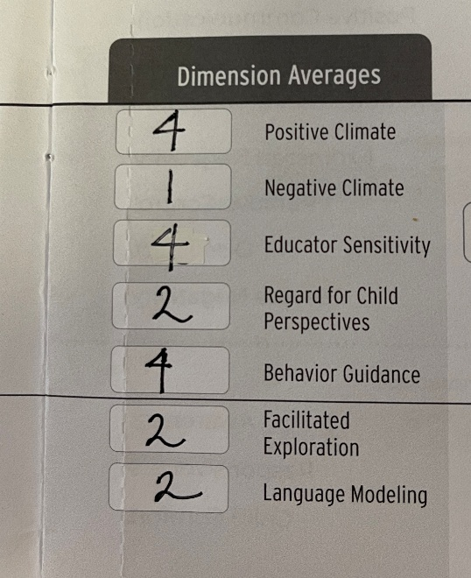
Example (Infant-Toddler) – Regard for Child Perspectives (RCP), Facilitated Exploration (FE), and Language Modeling (LM) are all assigned a score of a 2. You would address RCP in Emotional and Behavioral Support and address one dimension (either FE or LM) in Engaged Support for Learning.
H1
H2
3. If more than 1 dimension is assigned the same score in the same domain, use your judgment to determine which dimension was most strongly supported by lower-level behaviors.
L1
L2
4. If dimension averages are 6 or higher, there is no lowest scoring dimension to address.
NOTE: Always address Negative Climate in your lowest scoring dimension summary if the average score is a 3.5 or higher and notify the UL Lafayette CLASS administration immediately.
Before submitting your feedback into the Early Childhood Observation System (ECOS) ensure you have reviewed your writing for the following:
1. Proper spelling, punctuation, and grammar,
2. Uniformity of spacing and font throughout my summary statements,
3. Addressing each indicator in all summary statements with specific examples and frequency terminology; and
4. Providing only the number of examples for each indicator that MATCHES the frequency term assigned.

